**WEEK-4**

Hello World RESTful Web Service

HelloController.java

package com.cognizant.spring_learn.controller;

import org.slf4j.Logger;

import org.slf4j.LoggerFactory;

import org.springframework.web.bind.annotation.GetMapping;

import org.springframework.web.bind.annotation.RestController;

*@RestController*

public class HelloController {

private static final Logger ***LOGGER*** = LoggerFactory.*getLogger*(HelloController.class);

*@GetMapping*("/hello")

public String sayHello() {

***LOGGER***.info("START - sayHello()");

String message = "Hello World!!";

***LOGGER***.info("END - sayHello()");

return message;

}

}

SpringLearnApplication.java

package com.cognizant.spring_learn;

import org.springframework.boot.SpringApplication;

import org.springframework.boot.autoconfigure.SpringBootApplication;

*@SpringBootApplication*(

exclude = {

org.springframework.boot.autoconfigure.jdbc.DataSourceAutoConfiguration.class,

org.springframework.boot.autoconfigure.orm.jpa.HibernateJpaAutoConfiguration.class

}

)

public class SpringLearnApplication {

public static void main(String[] args) {

SpringApplication.*run*(SpringLearnApplication.class, args);

System.***out***.println("App is running...");

}

}

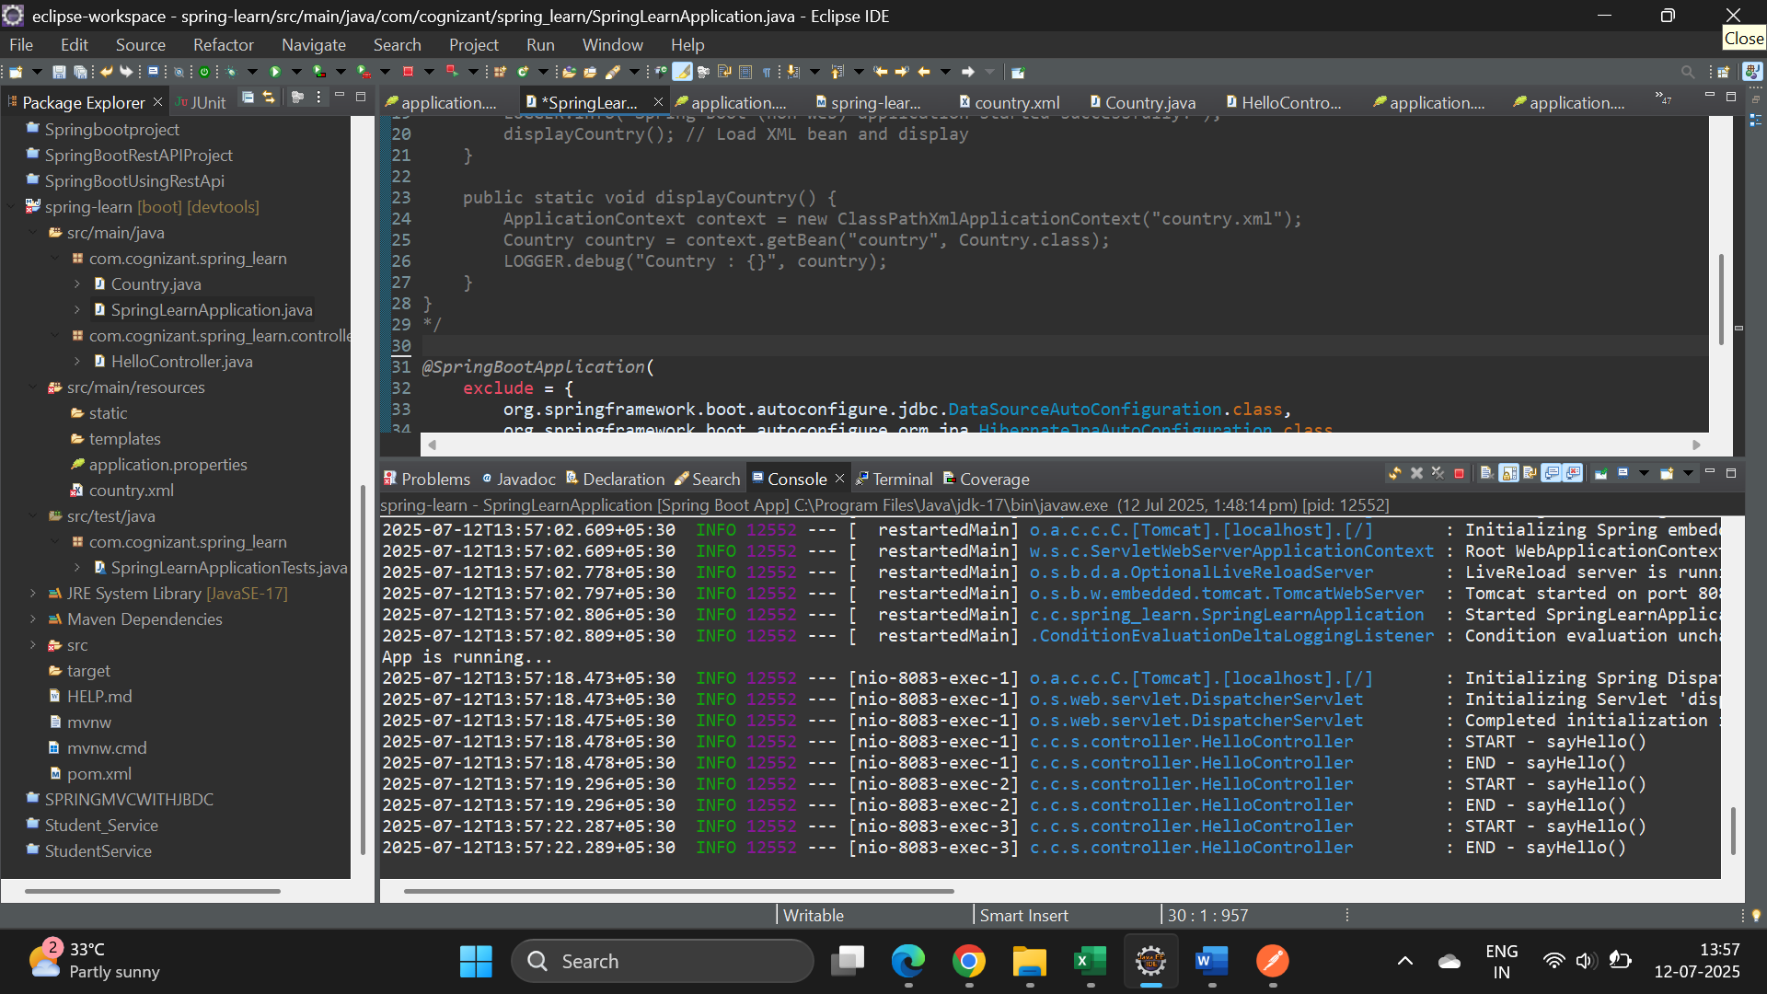

**OUTPUT**

**BROWSER**

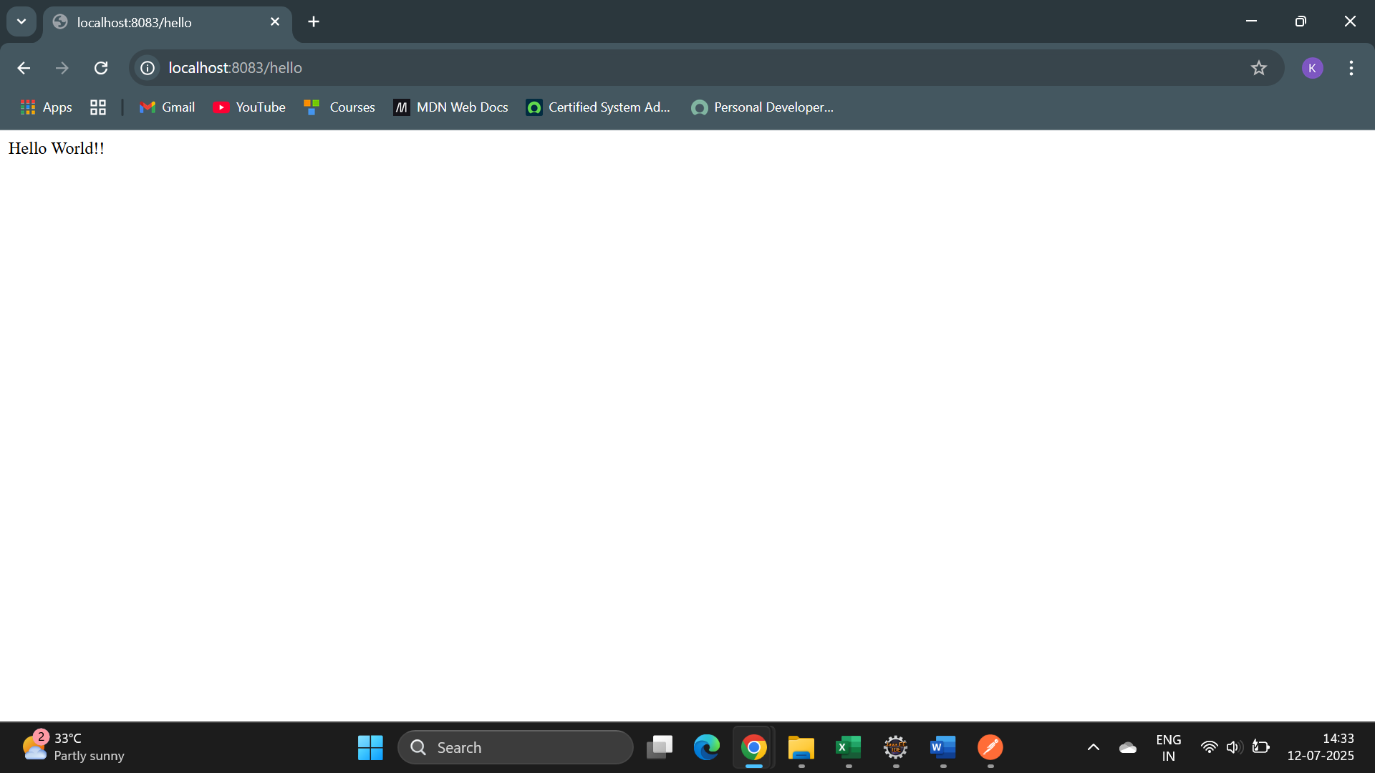

**POSTMAN**

